Result - Propose Minor

1) Python Libraries

Pandas

Numpy

Matplotlib

Seaborn

Wordcloud

Contraction

spacy

Snscrape - For scraping the data

seaborn

Matplotlib

Google trans

NLTK

2) Dataset -

The first dataset is scrambled from Twitter using snscrape.

<https://www.kaggle.com/datasets/arinjaypathak/indian-state-elections-2022-twitter-dataset>

3) Preprocessing Techniques

Translating the Hindi Text into English

Tokenization

Stopword Remove

Lemmatization

Punctuation Remove

De-tokenisation

Url Remove

Double Spaces, Indents removal

Removing Frequent Word and Rare words

4) Sentiment analyzer

VADER

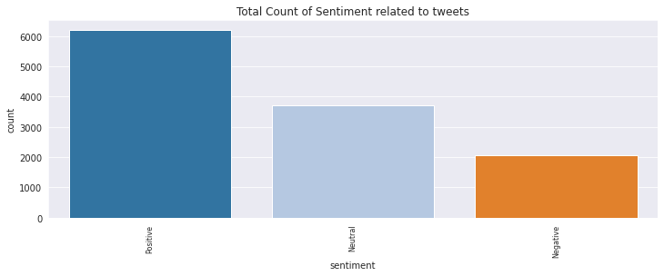

5) Wordcloud

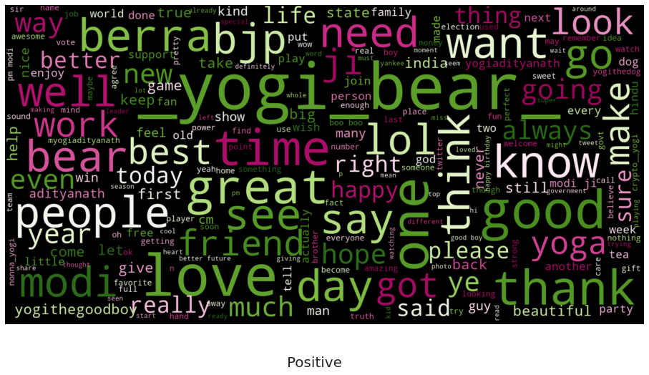

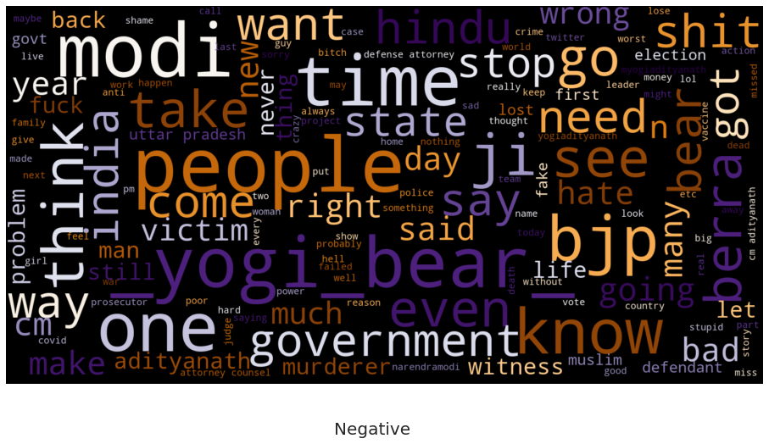

6) Feature Extraction Technique

TFidf

7) Classification Technique

LGBM

MLP

Here we have used Testblob to get the polarity and Subjectivity of each tweet.

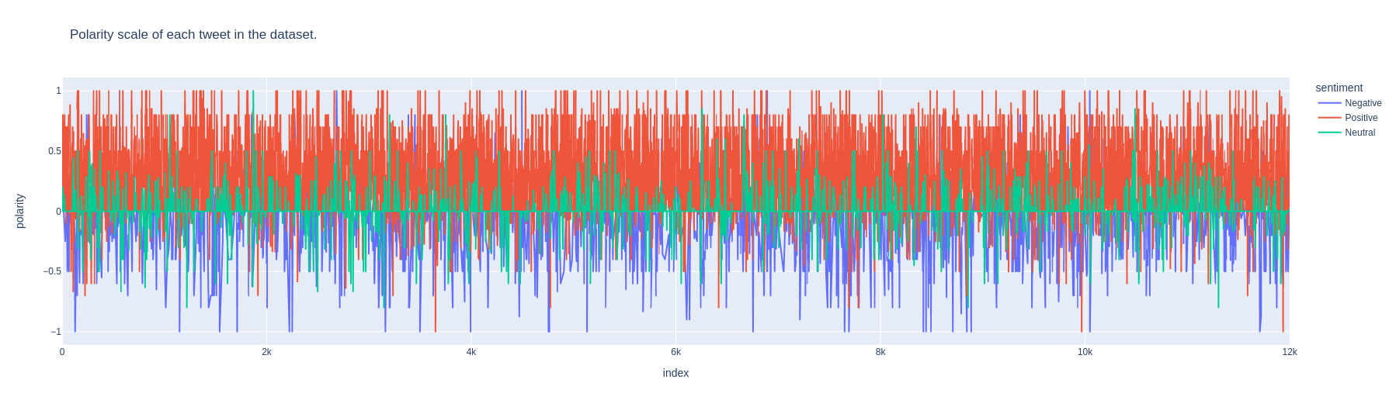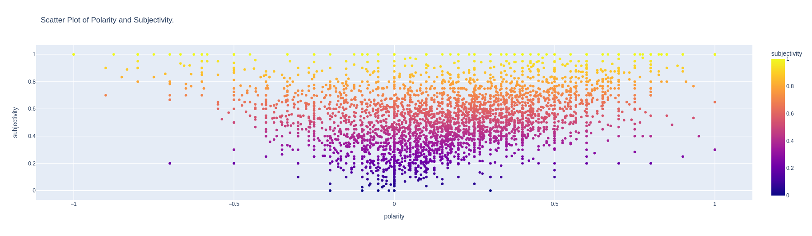

Here we are using the spacy library to identify the verb, noun, and pronouns in the sentence.

Also, here we are searching for a name and entity.

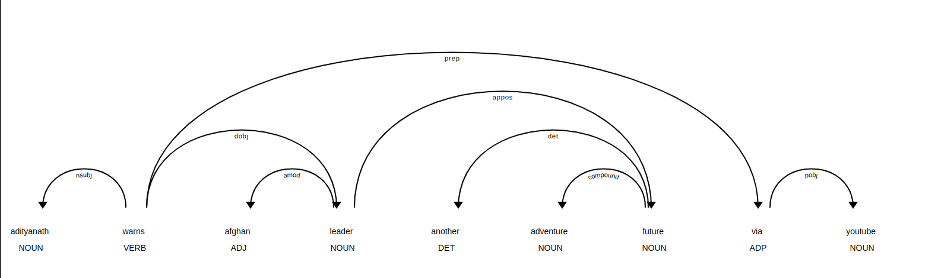

adityanath warns afghan **NORP** leader another adventure future via youtube

8) Results

1. LGBM

**Testing**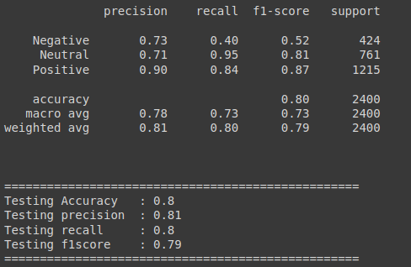

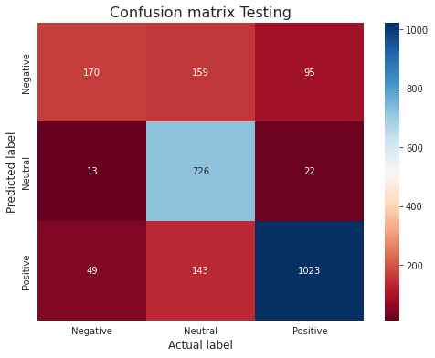

**Training**

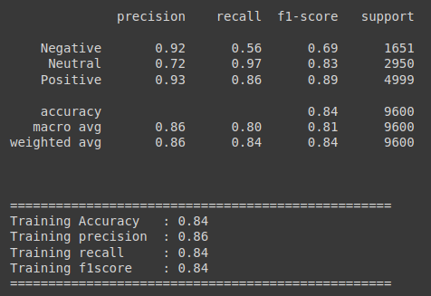

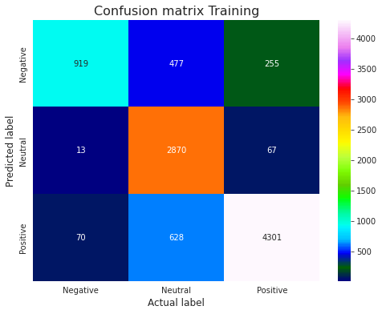

1. MultiLayer Perceptron

**Testing**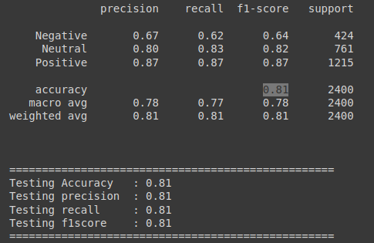

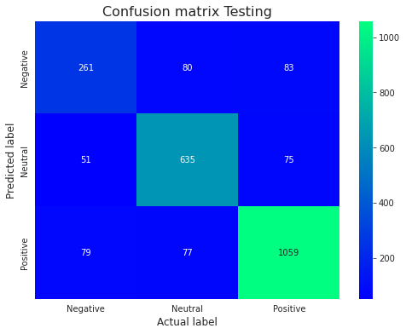

**Training**

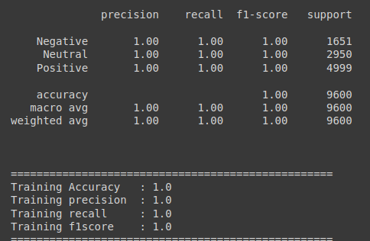

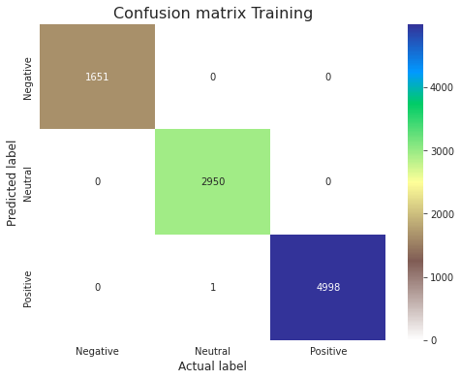

**Election Result Prediction Using Our LGDM Model**

